Design a code to print a pyramid based on level entered by user

import java.util.Scanner;

public class Pyramid {

public static void main(String[] args) {

Scanner scanner = new Scanner(System.in);

System.out.print("Enter the number of levels for the pyramid: ");

int levels = scanner.nextInt();

printNumberPyramid(levels);

}

public static void printNumberPyramid(int levels) {

int count = 1;

for (int i = 1; i <= levels; i++) {

// Print spaces

for (int j = 1; j <= levels - i; j++) {

System.out.print(" ");

}

// Print numbers

for (int k = 1; k <= i; k++) {

System.out.print(count + " ");

count++;

}

System.out.println();

}

}

}

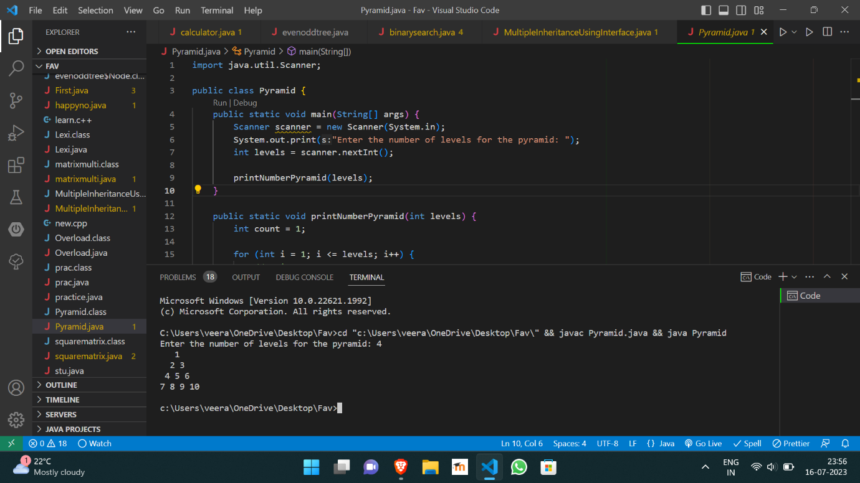

https://github.com/Veeragoutham04/Java_Lab/blob/main/Pyramid